DG INTERNS HUB

WEEK 1 | CYBERSECURITY INTERNSHIP REPORT
Lab Setup, Linux Administration, Networking Foundations and Learning Activities
Prepared by: Internship participant
Reporting period: Week 1
Document type: Weekly activity and evidence report
Report scope: This report summarizes Week 1 activities supported by submitted screenshots and working notes. Screenshots demonstrate selected milestones, not necessarily every command or challenge solution.
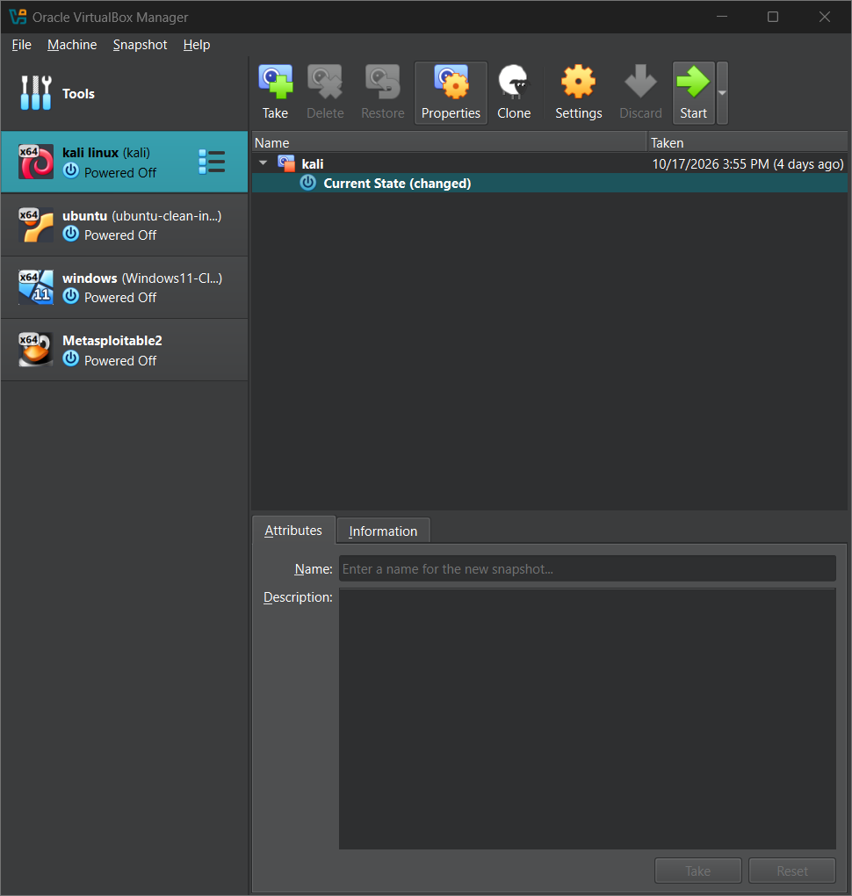

Figure 1. VirtualBox virtual machine list.

1. Executive Summary
Week 1 focused on building an isolated virtual lab, confirming connectivity among Kali Linux, Ubuntu and Windows 11, practising core Linux administration, and completing introductory cybersecurity learning activities using TryHackMe and OverTheWire Bandit. Written theory notes, individual writeups and a 30-command cheat sheet were prepared as separate submission artifacts.

2. Objectives
- Set up and use virtual machines for safe cybersecurity practice.
- Configure and test network connectivity.
- Practise Linux commands, user/group administration, permissions and cron.
- Study foundational cybersecurity and networking topics.
- Record TryHackMe and Bandit learning progress with evidence.

3. Lab Environment and Network
Virtual machine | Host-only IP | Purpose
Ubuntu | 192.168.56.101 | Linux administration and networking
Kali Linux | 192.168.56.102 | Security tools and Linux practice
Windows 11 | 192.168.56.103 | Cross-platform connectivity tests
Metasploitable2 | Not verified | Vulnerable practice VM; connectivity not verified

The host-only subnet was 192.168.56.0/24. NAT adapters were also configured for internet access where required. Avoid bridged networking for deliberately vulnerable machines.
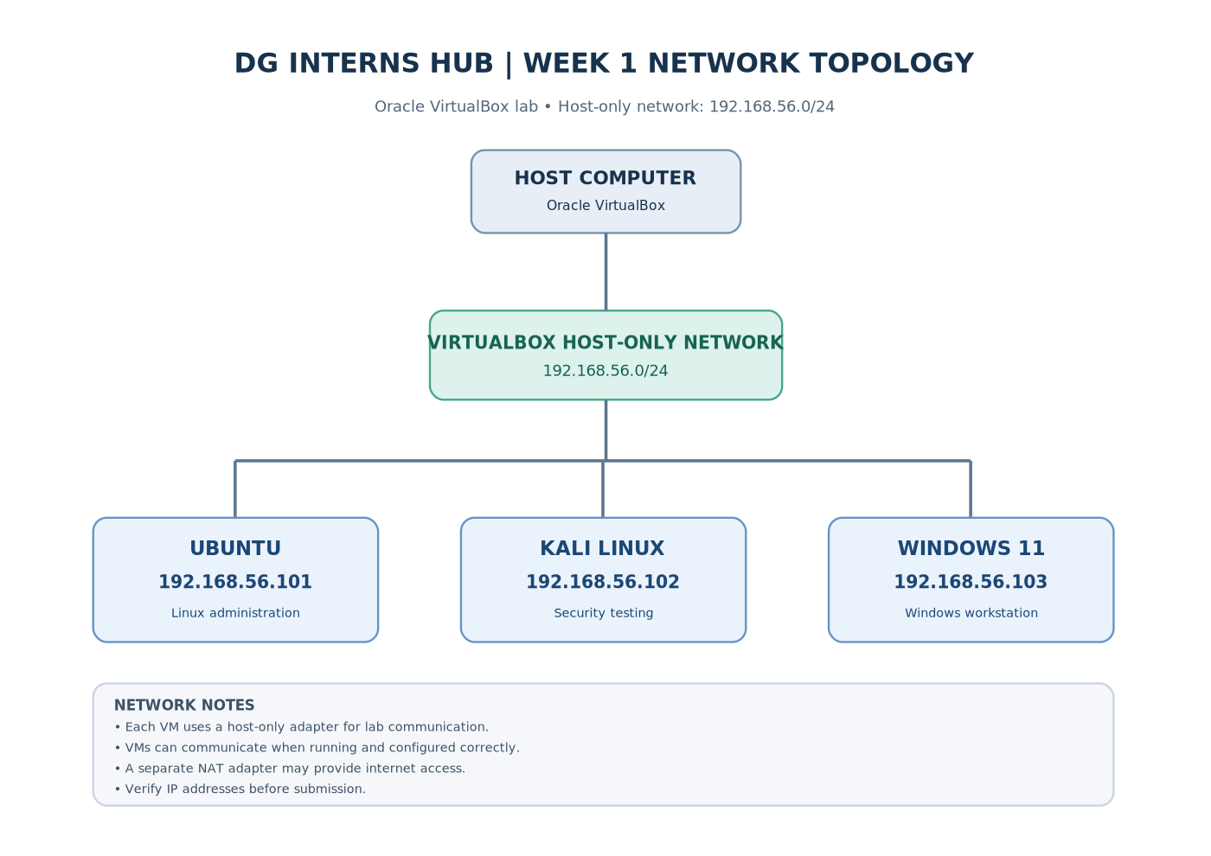
Figure 2. Week 1 network topology diagram.

4. Connectivity Testing
Source | Destination | Recorded result
Kali Linux | Ubuntu (.101) | Ping succeeded; 0% packet loss
Ubuntu | Kali Linux (.102) | Ping succeeded; 0% packet loss
Windows 11 | Ubuntu (.101) | 4 replies; 0% packet loss
Windows 11 | Kali Linux (.102) | 4 replies; 0% packet loss
Ubuntu | Internet (google.com) | Ping succeeded; 0% packet loss
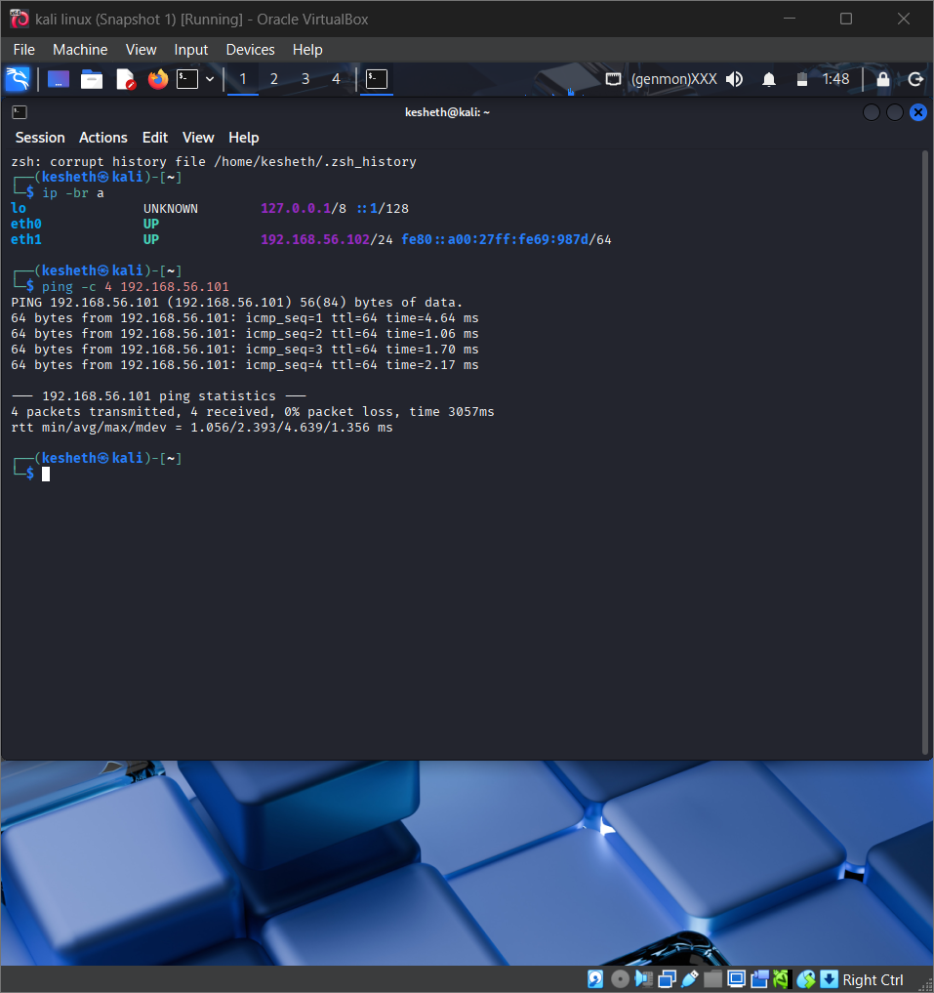
Figure 3. Windows-to-Ubuntu connectivity evidence.
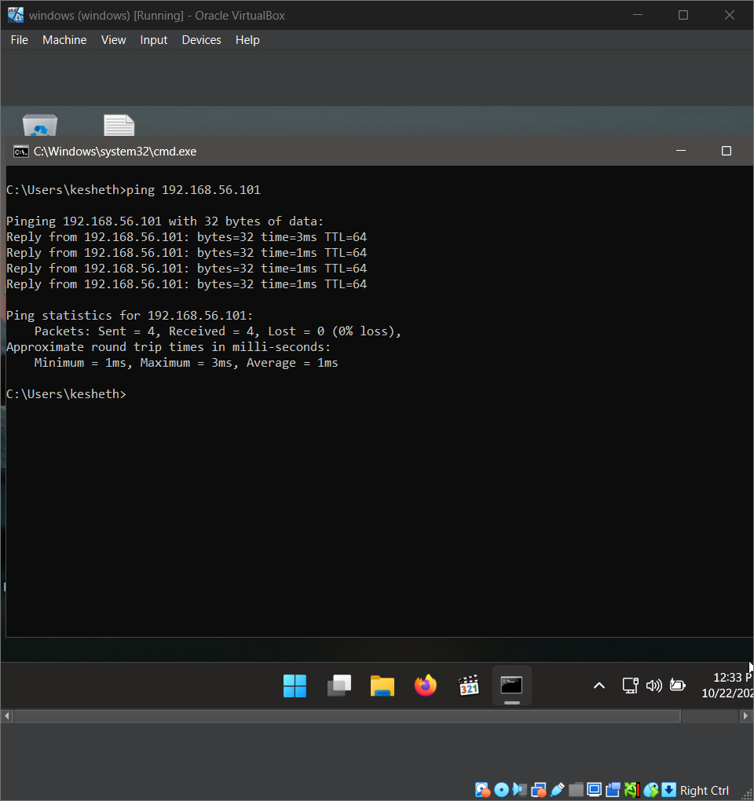
Figure 4. Kali-to-Ubuntu connectivity evidence.

5. Linux Administration Practice
Practice included creating users and groups, managing a shared directory, checking permissions, inspecting processes and ports, and configuring a cron job. Screenshots show several activities. One shared-folder screenshot showed permissions requiring correction; this report does not treat that configuration as verified until a final check confirms it.
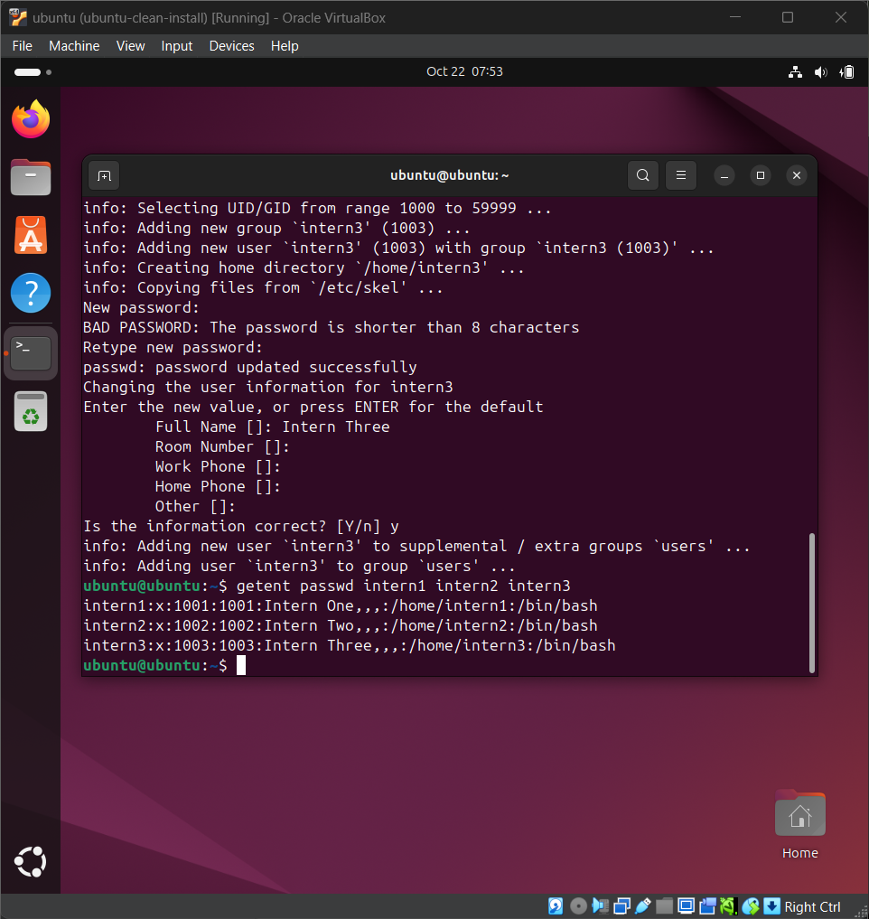
Figure 5. Linux user creation evidence.
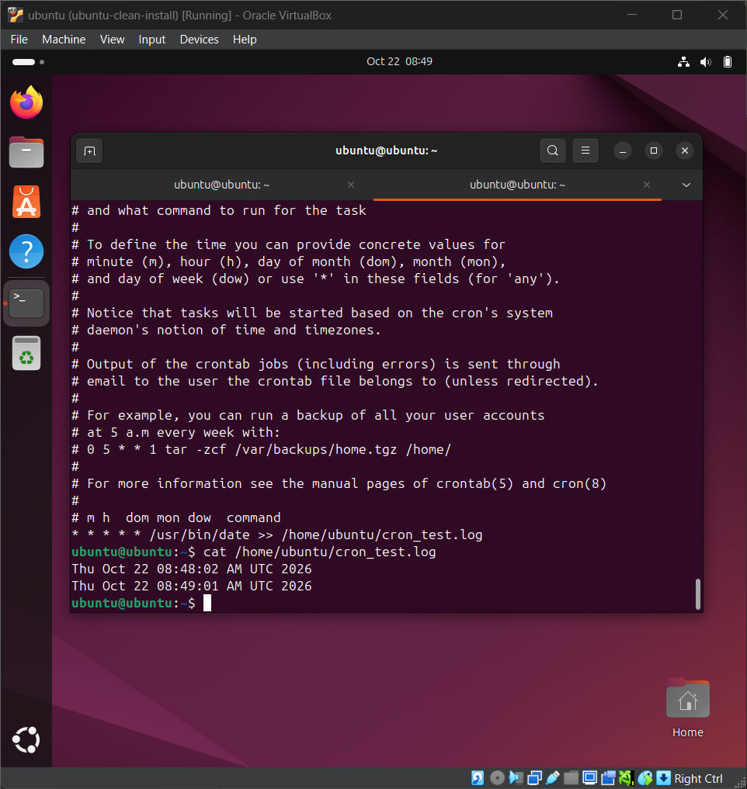
Figure 6. Cron job practice evidence.

6. Learning Platforms
TryHackMe: Evidence was provided for Search Skills, Learning Cyber Security, Linux Fundamentals Part 1, Introductory Networking, Networking Concepts, Intro to LAN, and Pyramid of Pain. A separate What Is Networking writeup was prepared; completion should be checked against the account before submission.
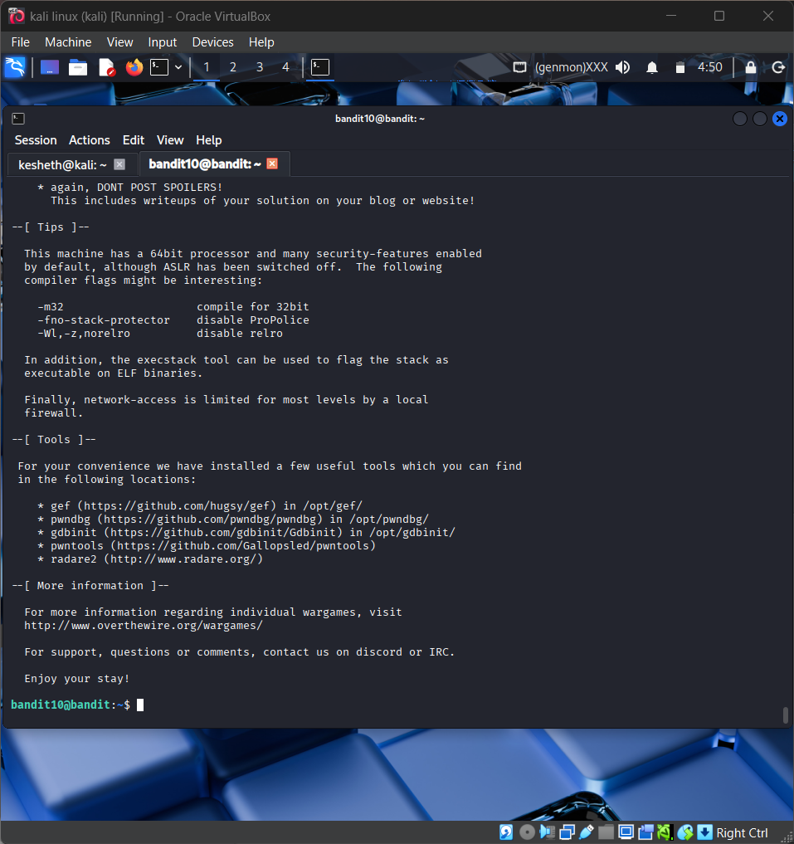
Figure 7. Example TryHackMe room evidence.
OverTheWire Bandit: Screenshots and draft writeups cover levels 0–11. Login/level screenshots indicate access and progress, but do not prove that each challenge solution is fully documented. Verify the writeups against actual commands used.
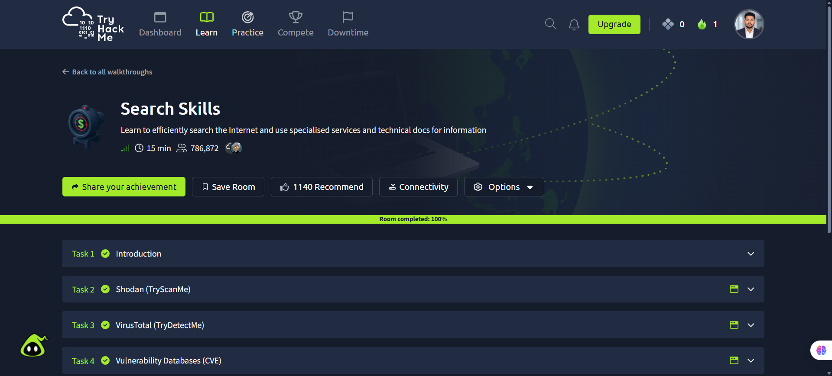
Figure 8. Example Bandit progress screenshot.

7. Theory Notes and Cheat Sheet
Eight separate theory documents cover cybersecurity and the CIA triad; SOC/VAPT/incident response roles; OSI and TCP/IP; networking identifiers and ports; Linux filesystem and permissions; threat/vulnerability/risk/exploit; virtual network modes; and Sri Lankan legal and ethical foundations. The Linux cheat sheet contains exactly 30 commands with their purpose and when to use them.

8. Outcomes and Outstanding Verification
Recorded tests support successful communication between the three main lab virtual machines. Before submission, verify shared-directory ownership and mode, ensure completed TryHackMe rooms match account records, and confirm Bandit writeup steps against actual session history. Metasploitable2 networking has not been verified in available evidence.

9. Conclusion
Week 1 established familiarity with isolated virtual lab setup, Linux and Windows network testing, core Linux administration, and introductory cybersecurity learning environments. The submission should include separate notes, challenge writeups, screenshot findings, 30-command cheat sheet, weekly report, presentation and README.

